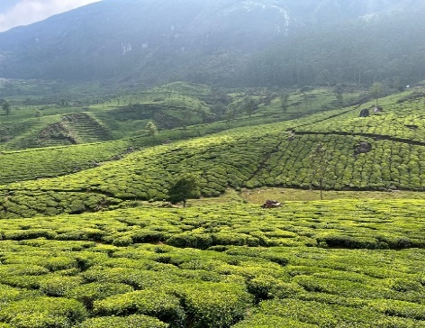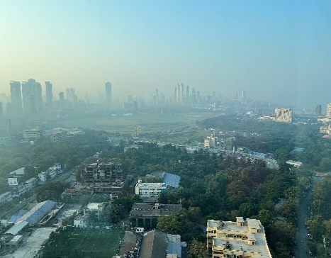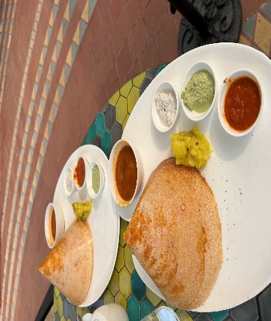

India: A Land Like Nowhere Else
By: Samir Jaluria
Last fall, I went to India with my wife for the first time in 3 years (and my first true post-pandemic international trip!). Having been to India nearly 20 times—mostly to visit relatives—this was by far the best! Just as India has evolved, progressed, and modernized over the years, so, too, has my appreciation for my ancestral homeland. Traversing across India from New Delhi in the North to Kerala in the South to Goa and Mumbai in the West was truly amazing. While in India, I realized that there were some common patterns that make up the soul of India.
India is truly one of the world’s most geographically and culturally diverse countries. India has 20+ semi-official languages in a country that is 1/3 the size of the U.S., leading to a plethora of amazing goods, food (I had everything from amazing dosas to fresh fish all in the same day), dances (I got the chance to see a traditional Kathakali performance in Kerala), religious beliefs, and customs. India is also a very geographically diverse country – ranging from the backwaters in Kerala to the hill stations of Himachal Pradesh; in fact, the terrain often changes every few miles. In addition, depending upon each region’s history, colonial remnants remain vis-à-vis the architecture, traditions, and food – ranging from the British influence in Delhi to the Portuguese influence in Goa. The diversity adds to the country’s beauty.
It is all about hospitality in India. I have been fortunate to crisscross the globe and have been to nearly 50 countries. No country’s hospitality matches what I have experienced in India. Period. There is a Hindi phrase: Mehmaan Bhagwan ka roop hota hai – Guests are the Gods (a should be treated that way)! In addition to valuing hospitality, India also has a labor surplus and can take advantage of the labor arbitrage (which is often cheaper than automation). The exemplary service afforded is especially true if you have discretionary money to spend (spoiler alert: a strong USD has and will always help). For example, while navigating the Kerala backwaters on our own, private houseboat, we had 3 full-time staff to cook, to serve and to captain the boat for us (and take care of us they did!) at a cost lower than a typical New York City hotel room.
Bollywood is everywhere. It is simply amazing to see the ubiquity of Bollywood’s actors and actresses on TV, in movies, in songs, at store openings, and hawking everything from cement to soda. While some Hollywood legends like Steve McQueen once promoted TAG Heuer watches, there is nothing to the extent that I have seen in India. On top of that, many of them have diversified by starting their own brands (e.g., Superstar Hrithik Roshan peddles his own athletic brand called HRX, etc.). Again, while Hollywood icon Reese Witherspoon has several successful brands like Reese’s Book Club, Draper James, and Hello Sunshine, she is a unique case here in the U.S.
India personifies the 70 / 30 rule. I absolutely love 70% of it and absolutely hate 30% of it. As referenced earlier, I love the food, the hospitality, the diversity, the culture, and about 70% of the people. What I hate is strong and requires some stomach in dealing with: the shoddy infrastructure (especially traversing the rural roads), the constant honking, people forcibly taking selfies with my wife because of her blonde hair, some of the noxious smells, the bureaucracy, the gulf between the rich and the poor, the pollution, and the lack of sanitation – to name several. That being said, the positive 70% strongly outweighs the negative 30%.
Go, but be flexible. My guidance for anyone that can do so is to go to India at least once in a lifetime. It’s an incredible experience with one caveat: go to another developing country first to experience some of the issues that India currently faces (otherwise the Indian experience might be too jarring). Without a doubt, going to India will change your life; just be prepared to be a little flexible as some things will have to be figured out on the spot. Also, as things start on “IST” (Indian Standard Time – which informally means at any time but on time!), build in extra time to deal with travel delays, bureaucracy, and infrastructure issues. If you take all of this into account, you will have fun!

